Linux Day 08 Task
Practise task
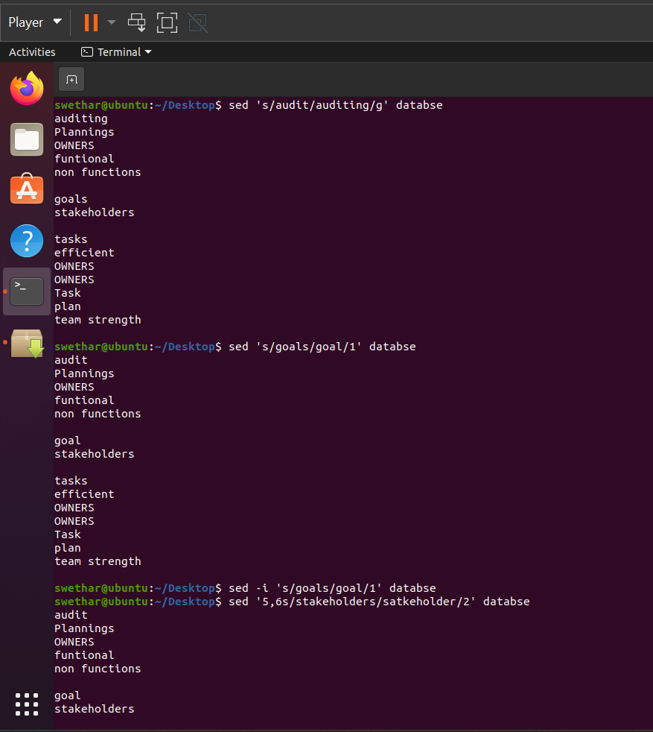
Additional task
1. What is diff between sed and grep command
Grep: Searches and prints lines matching a pattern
Sed : Edits/modifies text (replace, delete, insert, update lines)
2. How to delete the pattern only in 4th line and 7th line in a closed file?
sed -i '4s/pattern//g;7s/pattern//g' file.txt

3. How to remove blank lines using sed command?
sed '/^$/d' file.txt
4. How to delete the lines where the pattern is present using sed command?
sed '/pattern/d' file.txt

